FRIENDS OF HORSHAM PRARK - AGM, 28 OCTOBER 2025 - MINUTES
Attendees: 22
Committee: Sally Sanderson, Philippa Charman, David Hide, Steve Sandham, Alison Farrell, Zac Mukherhee, Cerys Thomas
HDC: Pete Crawford, Sorin Caraiman. Anna Champman
Denne Neighborhood Council: Chair, Trudie Mitchell
Friends and other volunteers: Laura Thomas, Felicity Owen, Chris Riahcrdson, Debbie Hepburn, Sue Beckett, Harrier Mayo, Margaret Cornwell, Jackie Alt, Neal Zimm, Jessica Ryan, Tina Hughes, Neil Marsh
Apologies: Ros Shiel, Ben Brace, Adam Tweed, Cllr David Skipp, Cllr Sam Bateman

Chair’s Report
Sally thanked everyone for all the hard work that led to us winning more awards for the park – these would not happen without the Friends working in partnership with the Parks & Countryside team and Horsham Denne Neighbourhood Council and without Harriet’s care of Park House Sensory Garden, plus all the others who volunteer in the park such as Strawford Centre.
- Green Flag for 7th year
- Gold for the second year in RHS S& SE in Bloom and winner of Large Park category
- Outstanding for 3rd year running in the ‘It’s Your Neighbourhood’ category.
The Park has benefitted from over 3500 hours from 1 Sept 24-31 August 2025
- Committee: 1040 hours: Meetings & liaison; Volunteer management; Finance & Policies
- Social media, Newsletter, Website; Events; Community engagement; Fundraising
- Wednesday Gardening/Conservation: 2290 hours
- Ribbon Border: 240 hours
- Litter picks: 40 hours
This is estimated at a value of over £100,000 (Committee equivalent to £50,000
Gardening equivalent to £50,000 + 4800 + 600= £55400).
Another indicator of the Friends’ strength as a community group was when Sir Ed Davey chose to work with us on his visit to Horsham where he wanted to highlight the value of community groups.
The benefits of Friends groups for Parks and Greenspaces has been reviewed by the National Federation of Parks and Green Spaces and their findings were shared - see Appendix.
All of this demonstrates the importance of protecting the park for future generations and we have made good progress on this in the last 12 months. The application for Fields in Trust protection is with the lawyers and we are hoping that this will be finalised in 2026.
The volunteers’ achievements in enhancing the park were listed:
- Lots of bulbs planted including the dazzling show at the new beds in North Street
- The pond continues to improve with additional plants, some taken from elsewhere in the park/donated
- Lots of work on maintaining the paths so the park is accessible and welcoming
- Sustainability –now getting coffee grounds each week from Koffie in the Park for composting and we have enlarged our composting area and activities.
- Using our 1200litre water butt throughout the summer, and the new tree in PHSG befitted from the water bag and survived (unlike the three cherry trees at North Street). We hope this informs and inspires the public too.
- We have been experimenting at the meadow and on the bank with wildflowers and Alder Buckthorn for butterflies, following David Bridges suggestions at last year’s AGM
- Creating our own plant supports from willow
- We shared some of the plants and bulbs taken out of the HNG with the Ribbon Border team when preparing it for replanting this Autumn
The committee have been busy too, although some of the work is less visible
- Funday Sunday in the park is an opportunity for public engagement
- We provided a set of 4 table tennis bats and balls to borrow – looked after by the café
- Some improvements to the website, especially now members can sign up there and we now have 571 subscribers to the newsletter
- Our Facebook page has been energized, now making lots of noise for example over 1000 views of a recent video in under 2 hours
- Two litter picks – thanks to loyal supporters who turn up each time
- A visit with Horsham Green Spaces to Collyers during Green Week and to Strawford Centre Culture Day
- Research on the social history of the Park
HDC has also been continuing to invest in the park over the last year and currently:
- Recent mural at North Street entrance to disguise the electricity box
- Path improvement for safety between Collyers entrance and Pavilions – further work on path in the Autumn
- Plans are being finalised for staged replacement of the avenue of failing fastigiate oaks – the aim is to plant between and to provide more shade for heat cooling in our hotter summers. Many options have been considered over the past 3 years and the choice is now down to Hornbeam or Liquid Amber. The planting will be this winter with young standard trees about 3-4m high. The oaks would then be removed in the winter of 2027-28, once their replacements have become established.
- The paths in PHSG will also be resurfaced in the spring. This is great news as we have been lobbying for this for some time.
In the past we have looked at several options for topping the rough marble columns in PHSG – none of which have worked. Sorin has come up with the suggestion that a deep black metal collar could be attached to each (covering the rough and broken edges) and then filled with the same resin gravel material as the path surfacing. This would smarten them up and create perching places that don’t fill with water! HDC don’t have the budget for the metal collars as each will cost approximately £100 and there are six of them, but they would pay for the additional filler resin-gravel. Therefore, as part of our renovation project for the garden, do we want to fund these collars? It looks like using our money for a flagpole isn’t going to work out, so we do have the funds to do this.

Treasurer’s report
Philippa provided a review of the Surplus/(Loss) once our costs have been covered since we started. This showed the impact of COVID. It also shows we have built up a surplus.
- 2018 £467
- 2019 £267
- 2020 1615
- 2021 -£1172
- 2022 -£50 2
- 023 £964
- 2024 £429
- 2025 £744
- Total held today £3264
Every year our costs amount to around £1000. Our income comes from our quiz and the Horsham lottery. In October the lottery hit a milestone raising £4000 in total. We received £96 funds this month.
There was a discussion on spending surplus £2387 funds, retaining £877 to ensure we have sufficient to cover running costs should we have fewer people donating via the lottery or we are not able to run a quiz.
After a discussion and a vote, it was agreed to go ahead with funding the metal collars for PHSG and it was suggested some people might like to fund a column.
Other suggestions included:
- Building on the tennis table bats, by providing a games box with frisbees etc to borrow for spontaneous play.
- Spending on colourful bedding as colour is enjoyed by visitors to the park.
- (After the AGM the Wednesday volunteers have requested we buy more of our branded tabards).
Make Space for Girls
Guest speaker, Anna Chapman, HDC Parks & Countryside Development Manager
Anna’s presentation was on how to make sure the park is an inclusive space for girls.
- Girls may feel excluded from traditional recreation areas dominated by competitive or physical activities.
- Boys may feel pressure to engage in aggressive or performance-based activities.
- Gender diverse youth often lack spaces where they feel safe, seen and respected.
This is needed more than ever because of cuts to youth services and because external spaces are not moderated. 90% of park usage is by boys (football, skate parks, MUGA courts, bike tracks) and so there is a need for provision of outdoor facilities for girls, young women and gender diverse young people.
Facilities and their location need to consider the following:
- A well-used space is a safe space
- Clear sight lines
- Close proximity to local amenities: toilets, drinking water, cycle parking, CCTV, help points
- Links to public transport
- Access needs to include clear signage, well-lit entry and exit point, wide paths
- Layout should include: zoning, sense of place, avoid dark secluded spots, ambient lighting
- Equipment should provide
  - Social seating
  - Challenge
  - Shelter
- Provision should also consider a range of needs for: active, social, creative, reflective
The management and maintenance of space for girls require: regular maintenance, signage, regular feedback, local patrols, organised group activities.
The place recommended for a facility in the park is near the bee bed where the criteria are all met: good sight lines, train and bus access, accessible path, near to bike park, toilets and refreshments in the Pavilions and a sense of place.
Anna showed three example pieces of equipment that could be used in this area providing sheltered seating/stage, sociable seating
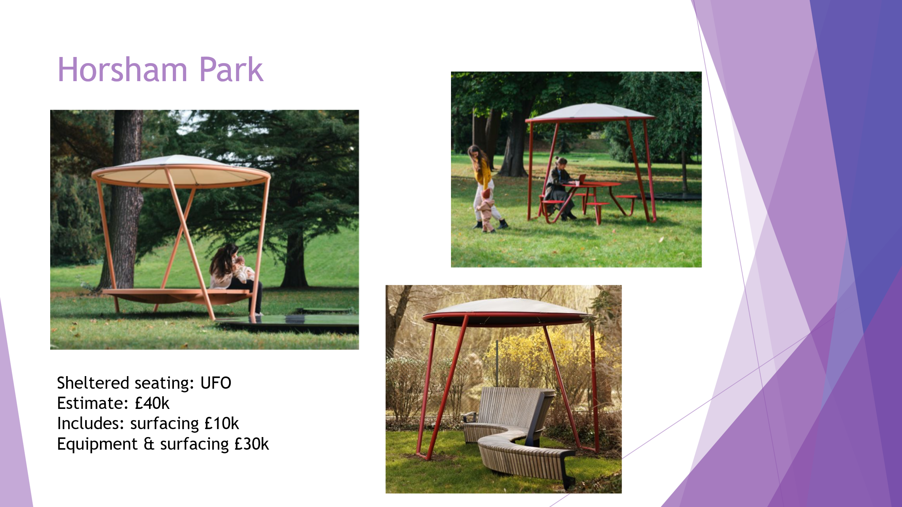
This was discussed as well as the request that the Friends apply for grant funding for this equipment. HDC will be applying for a capital budget for next year, but if the Friends raised money, then HDC budget could be used to provide similar equipment in other areas in the District where there are no equivalent Friends groups to access funding.
Key points raised in the discussion were:
- The cost is high – as everything in parks seems to be, in order to be robust
- The Scandinavian open style was popular
- Anna was asked if British manufacturers make equivalent designs. and at the moment this is not happening. British designs are heavier, more closed and more obtrusive. The Scandinavian manufactures are ahead on this.
- Some concern was expressed about more ‘clutter’ in the park
- Others thought that it is important to provide facilities such as these so the park is inclusive, especially as there is still acres of open space in the park
- Some discussion around whether near the other outside gym would be an alternative space and nearer to Collyers
- Concern was expressed about how long the canvas roofing might last and whether ASB damage would be likely. The roofing is likely to need replacing every 3 years.
- As part of this discussion, David Hide commented that the price of coffee in the park is not affordable to the young and to many residents. He requested that when HDC renew leases they consider affordability of the leaseholder’s provision of coffee and catering so that young people can afford it and so the park is inclusive.
- These facilities would be attractive to everyone, so we would need to consider how to raise awareness amongst the target population that these facilities are available for them to enjoy.
- Most people thought that this would be a good enhancement to the Park’s facilities and that the Friends should investigate grant funding opportunities.
The Chair thanked Anna for her interesting and thought-provoking presentation and the enthusiasm it had generated.

Appendix
