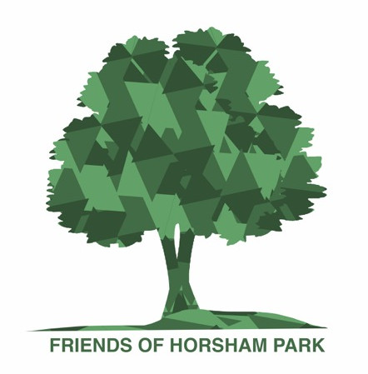
Pledge to protect Horsham Park
The Friends of Horsham Park is a group of volunteers who work to protect, enhance and promote our beautiful park as a place of recreation and enjoyment, for current residents and future generations.
Horsham Park achieved ‘Local Favourite’ status last summer from the national charity Fields in Trust, as well as winning two In Bloom awards and a Green Flag. Improvements to the Park are ongoing and designed to make it a space for people of all ages to enjoy – from youths on the new skate park to wheelchair users visiting the Park House Sensory Garden.
Ahead of the local elections next month, we are asking all candidates to pledge their support for Horsham Park and other green spaces in Horsham District, using the Fields in Trust pledge as a guideline: https://www.fieldsintrust.org/pledge: . Please pledge that if elected, you will:
- Seek to protect Horsham Park in perpetuity
- Value Horsham’s parks and green spaces for their vital contribution to residents’ physical and mental wellbeing. According to research by Fields in Trust, parks and green spaces generate £34.2 billion worth of physical and mental health benefits each year.
- Champion the important public service parks and green spaces provide locally
- Advocate for policies that safeguard parks and green spaces
- Encourage sufficient and equitable provision of parks and green spaces for all
- Support community volunteers in our Park and other green spaces
You can pledge your support by returning this to chair@friendsofhorshampark.co.uk
There is more information on the research by Fields in Trust on the benefits green spaces provide on their website.

