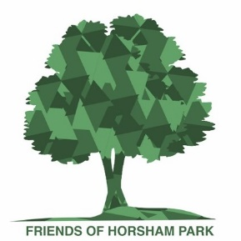
14 July 2022
Spend summer on the bench in Park House Sensory Garden!
The Park House Sensory Garden in Horsham Park has a new addition designed to make it an even more enjoyable space to enjoy the summer: a curved bench, installed by the Friends of Horsham Park to commemorate the garden’s 30th anniversary.
The curved bench was custom made, thanks to generous contributions from Sussex Community Foundation and Royal Sun Alliance. It is sited in a peaceful corner, mostly in shade, making it a perfect spot for groups or families to enjoy the garden.
In designing the bench, the Friends consulted local groups, and their needs were taken into account, for example: seating in the shade; seating with arms to ease standing up, and space alongside it for wheelchairs and buggies. It seats eight people and its curved shape helps deaf/hard of hearing people to communicate more easily with others, compared to a straight bench.
Meanwhile, on the other side of the garden, the Friends have refurbished a love seat, and are running a competition on social media to encourage visitors to take a photo of them sharing the seat with a loved one.
So far, the Friends have received photos of newly-weds, pairs of friends and dog-owners with their pooch – so be as creative as you want! To enter, take a photo with the loveseat and post on your Instagram using #loveatfirstseat and tagging @horshampark or send your picture via email to communityfohp@gmail.com
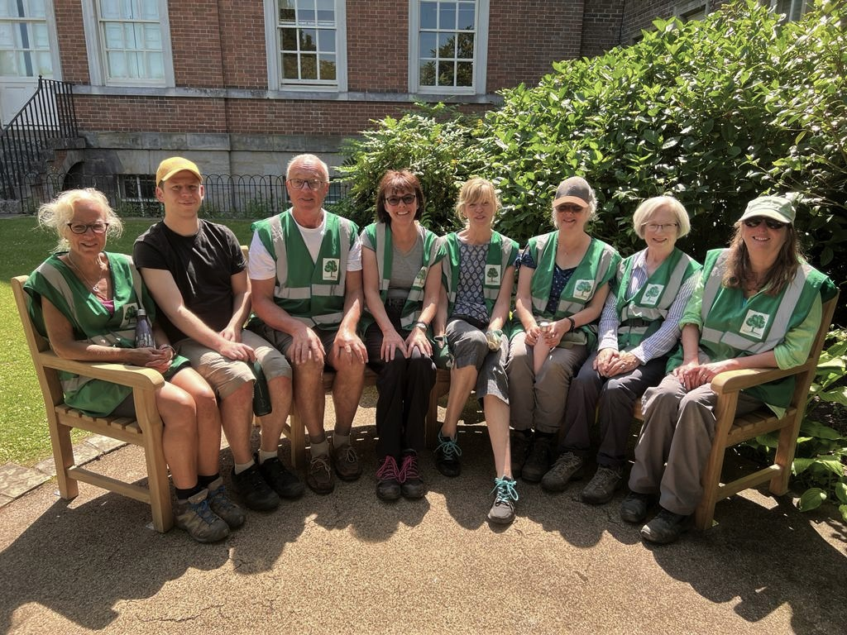
Friends volunteers enjoy the new curved bench in Park House Sensory Garden
The Friends of Horsham Park aims to protect, enhance and promote Horsham Park as a place of recreation and enjoyment for the long-term benefit of everyone. Anyone with an interest in the Park is welcome to join the Friends and get involved in their activities, which include a weekly gardening session. For more information, contact chair@friendsofhorshampark.co.uk
-ends-
For further information: Sally Sanderson
chair@friendsofhorshampark.co.uk
07714 100826

